**R Lab Assignment**



**Submitted By:**

Abhishek Maira

101703046

COE2

**Dataset link:** [**https://vincentarelbundock.github.io/Rdatasets/datasets.html**](https://vincentarelbundock.github.io/Rdatasets/datasets.html)

**About Dataset:** Overseas departures from Australia: permanent departures, long-term (more than one year) residents departing, long-term (more than one year) visitors departing, short-term (less than one year) residents departing and short-term (less than one year) visitors departing. January 1976 - November 2016.

|  |  |
| --- | --- |
| permanent | permanent departures from Australia. |
| reslong | long-term resident departures from Australia. |
| vislong | long-term visitor departures from Australia |

**Software Used:** RStudio,git

Here’s the screenshot of the code (I’ve included the script file in the email) :

I’ve saved data like Mean, Median, Mode, Standard Deviation and Variance in the matrix displayData.

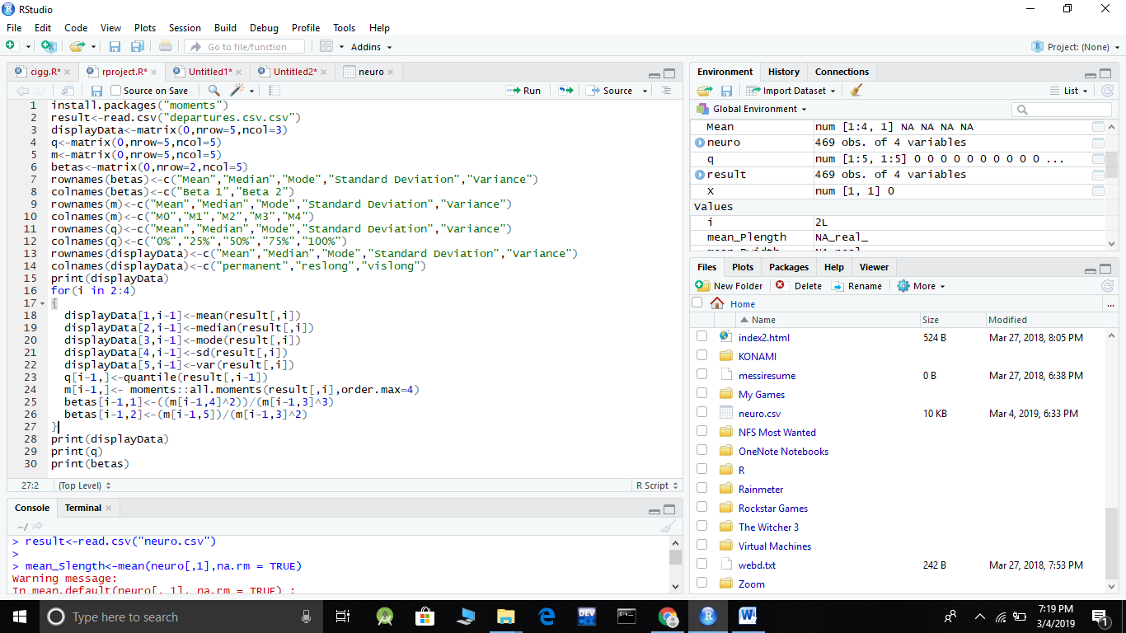

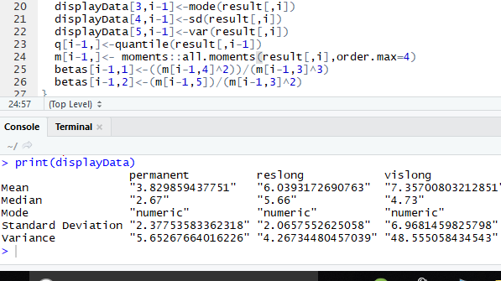

I’ve saved quantiles of each column in a separate matrix called ‘q’:

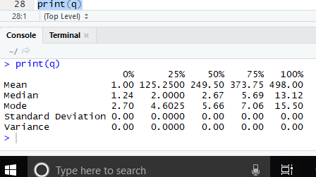

Here’s the separate matrix, saved as ‘m’, which I’ve formed for all the moments:

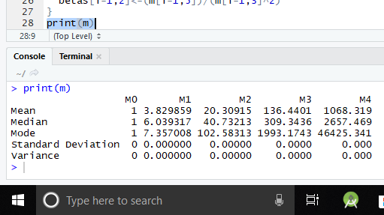

I’ve saved both the betas in the separate matrix which I’ve named ‘betas’ and it returns:

